Phase 2 — ALB + Target Group + Launch Template + Auto Scaling Group

🧭 Objective
Convert your static setup into a self-healing, auto-scaling architecture:
User → ALB → Target Group → Auto Scaling Group → EC2 (dynamic)
🏗️ Architecture Overview
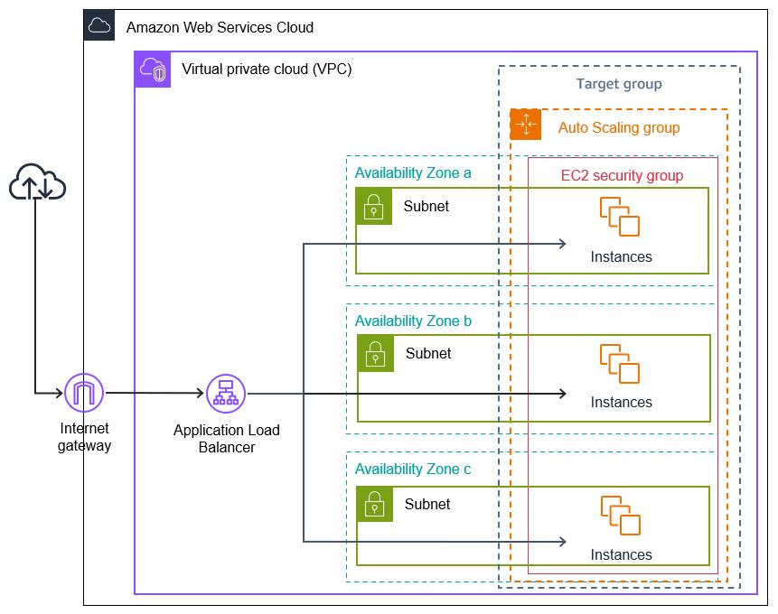
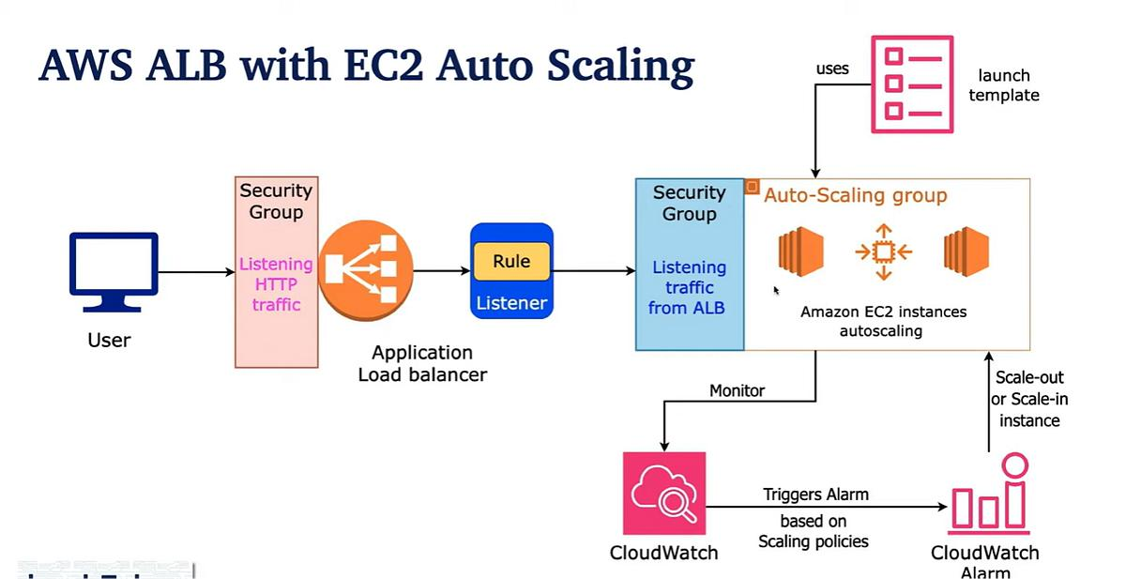
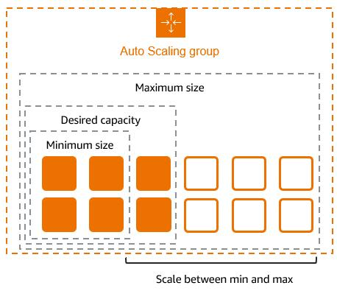
6

🔧 Prerequisites
- Phase 1 completed
- Existing:
  - ALB (alb-web)
  - Target Group (tg-web)
- Basic understanding of:
  - Amazon EC2
  - Elastic Load Balancing

🚀 Step 1: Create Launch Template (LT)
📍 Navigation
EC2 → Launch Templates → Create Launch Template

⚙️ Configuration
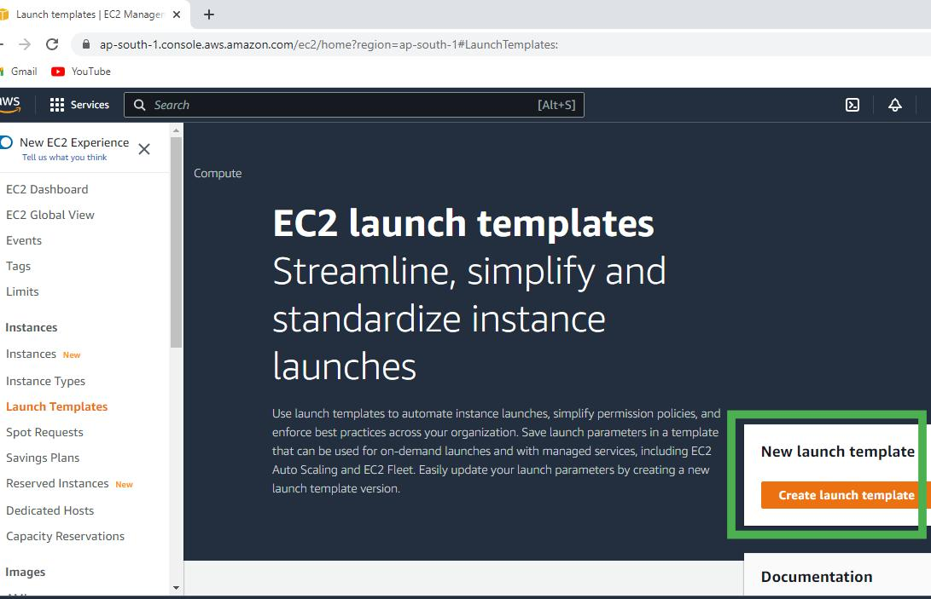
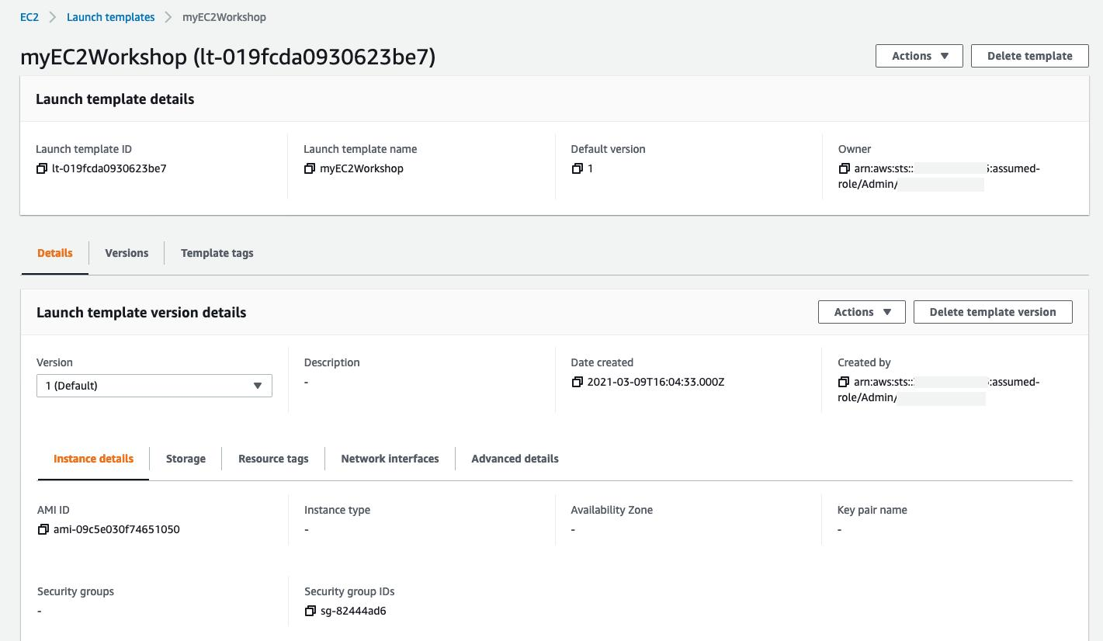
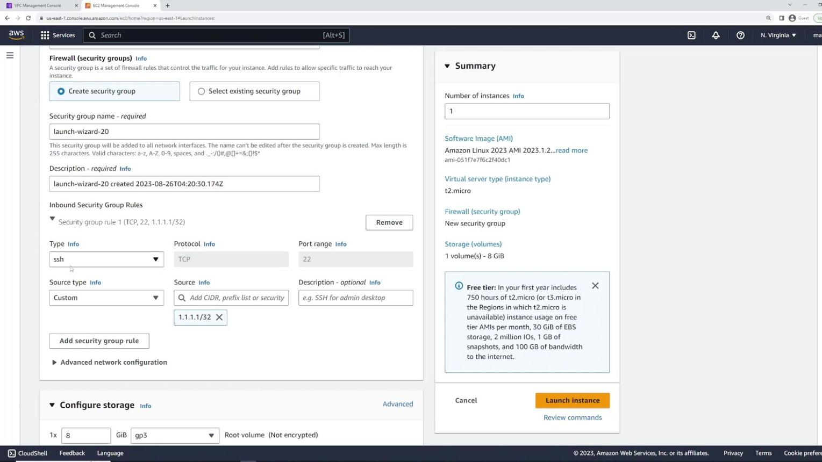
7

🔹 Basic Details
Parameter | Value
Name | lt-web
AMI | Amazon Linux 2
Instance Type | t2.micro
Key Pair | Same as Phase 1

🔹 Security Group
Allow:
- SSH (22)
- HTTP (80)

🔹 User Data (IMPORTANT)
#!/bin/bash
yum update -y
yum install httpd -y
systemctl start httpd
systemctl enable httpd
echo "Hello from ASG $(hostname)" > /var/www/html/index.html

✅ Create Launch Template

🚀 Step 2: Create Auto Scaling Group (ASG)
📍 Navigation
EC2 → Auto Scaling Groups → Create Auto Scaling Group

⚙️ Configuration
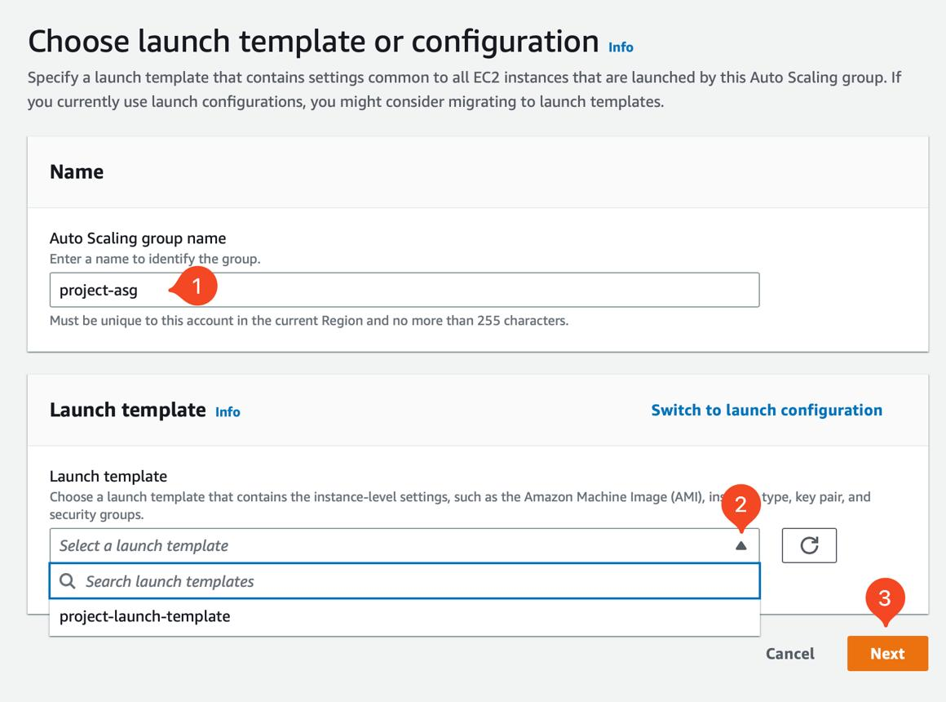
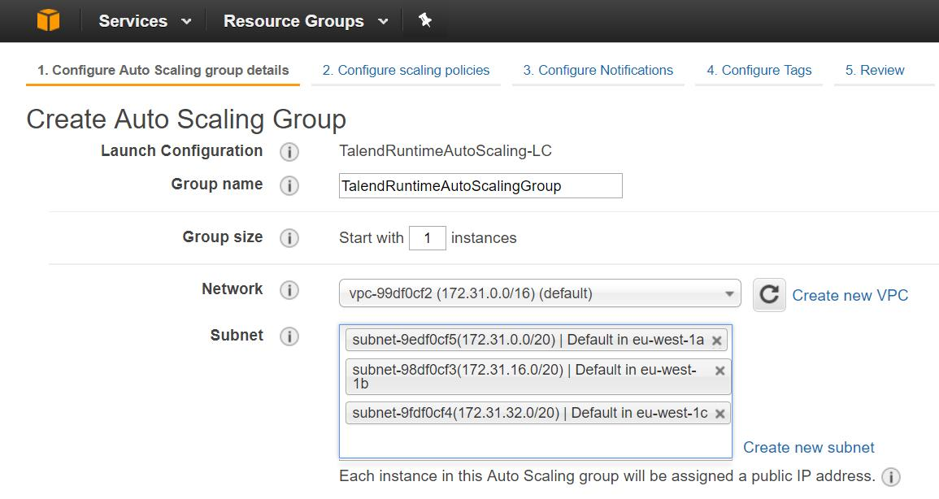
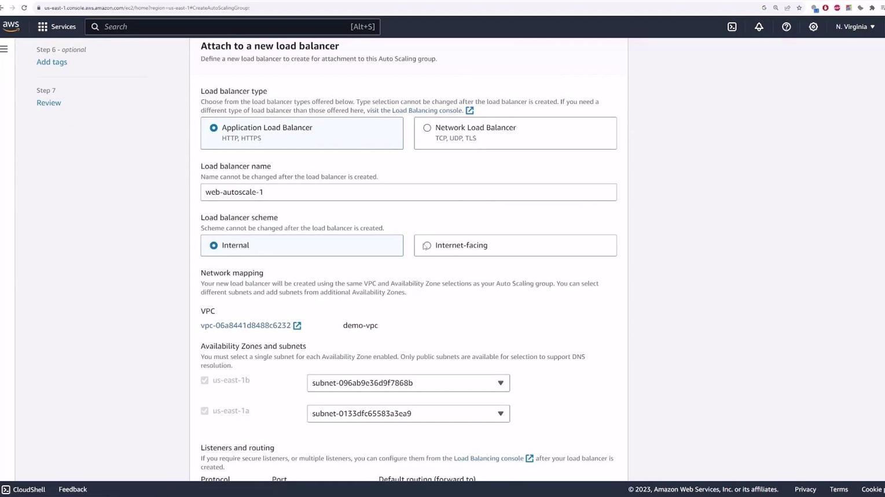
8

🔹 Step 2.1: Choose Launch Template
- Select:
👉 lt-web

🔹 Step 2.2: Network
Setting | Value
VPC | Same as ALB
Subnets | Select 2 AZs

🔹 Step 2.3: Attach to Load Balancer
- Select:
👉 Attach to existing load balancer
👉 Choose Target Group: tg-web

🔹 Step 2.4: Group Size
Parameter | Value
Desired Capacity | 2
Min | 1
Max | 4

🔹 Step 2.5: Health Check
- Type: EC2 + ELB
- Grace period: 300 sec

✅ Create ASG

⚠️ Step 3: Clean Up Old EC2 (IMPORTANT)
👉 To avoid confusion:
- Go to EC2 → Instances
- Terminate:
  - web-1
  - web-2
👉 Now only ASG-managed instances remain

🧪 Step 4: Validate Setup
📍 Check Instances
- Go to EC2 → Instances
- You should see:
AutoScaling instances created automatically

📍 Check Target Group
- Go to Target Groups → tg-web
- Status:
Healthy

📍 Test ALB
Open:
http://<your-alb-dns>

🔁 Expected Output
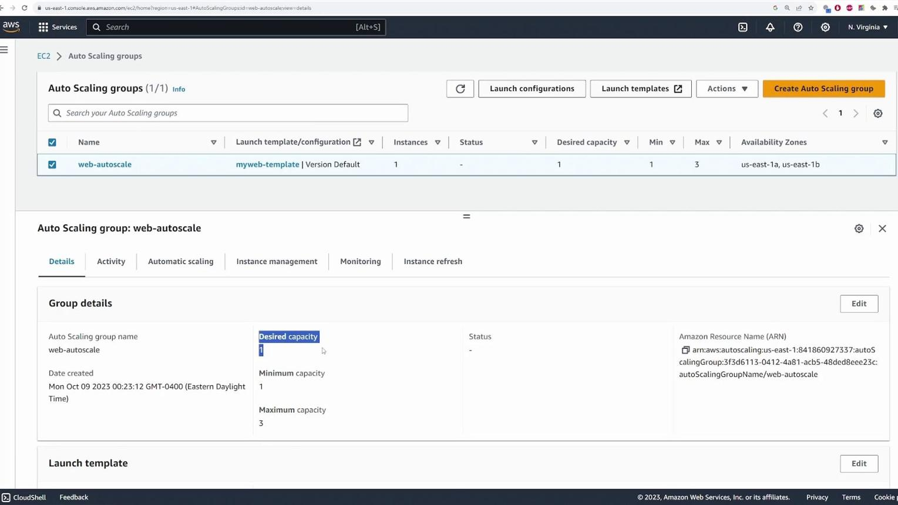

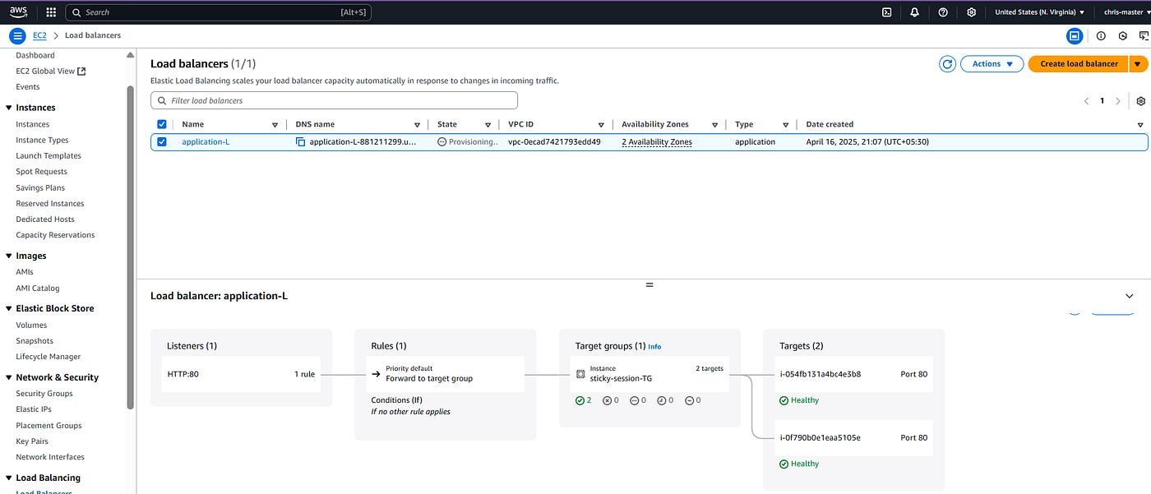
7
Hello from ASG ip-xxx-1
Hello from ASG ip-xxx-2

📈 Step 5: Add Scaling Policy (CPU Based)
📍 Navigation
EC2 → Auto Scaling Groups → asg-web → Scaling Policies

⚙️ Create Policy
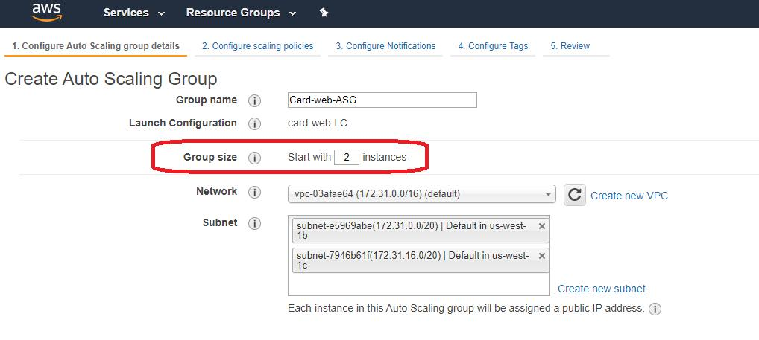
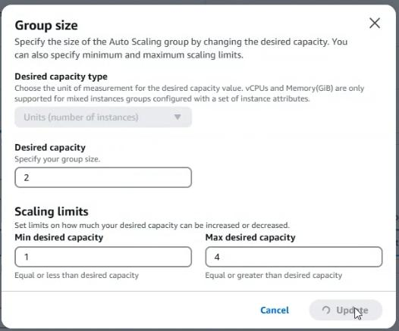
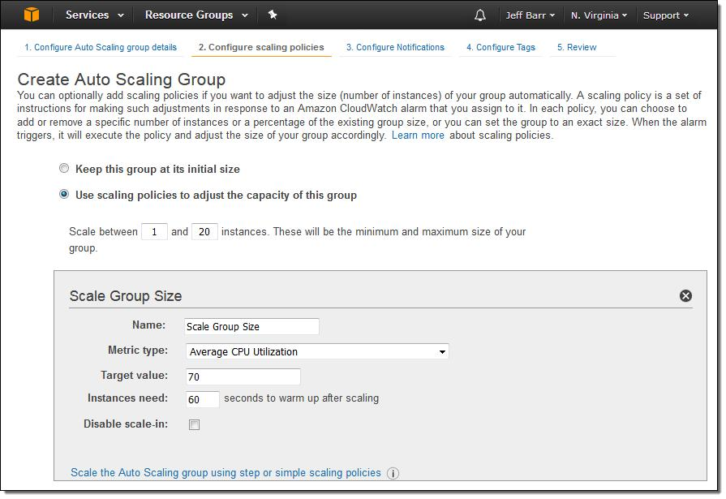
5

🔹 Configuration
Parameter | Value
Policy Type | Target Tracking
Metric | Average CPU Utilization
Target | 50%

✅ Save Policy

🧪 Step 6: Test Auto Scaling
🔥 Generate Load
SSH into one instance:
sudo yum install stress -y
stress --cpu 2 --timeout 300

📈 Observe
- Go to ASG → Activity
- Watch:
  - New instance launch when CPU > 50%

🎯 Expected Behavior
Scenario | Result
High CPU | Scale OUT (add instances)
Low CPU | Scale IN (remove instances)

🧠 Key Concepts
🔹 Launch Template
Blueprint for EC2 instances
🔹 Auto Scaling Group
Manages:
- Instance count
- Health
- Scaling
🔹 Integration Flow
ALB → Target Group → ASG → EC2

🧪 Practice Exercises
- Kill one instance → ASG recreates it
- Increase max to 6 → observe scaling
- Change user data → create new LT version → update ASG

🧹 Cleanup Strategy
Scenario | Action
Continuing soon | Keep ASG + ALB
Taking break | Delete ASG + ALB

📌 GitHub README Suggestion
## Phase 2: Auto Scaling + Load Balancing
- Launch Template setup
- Auto Scaling Group configuration
- Scaling policies
- Testing auto scaling
- Screenshots

